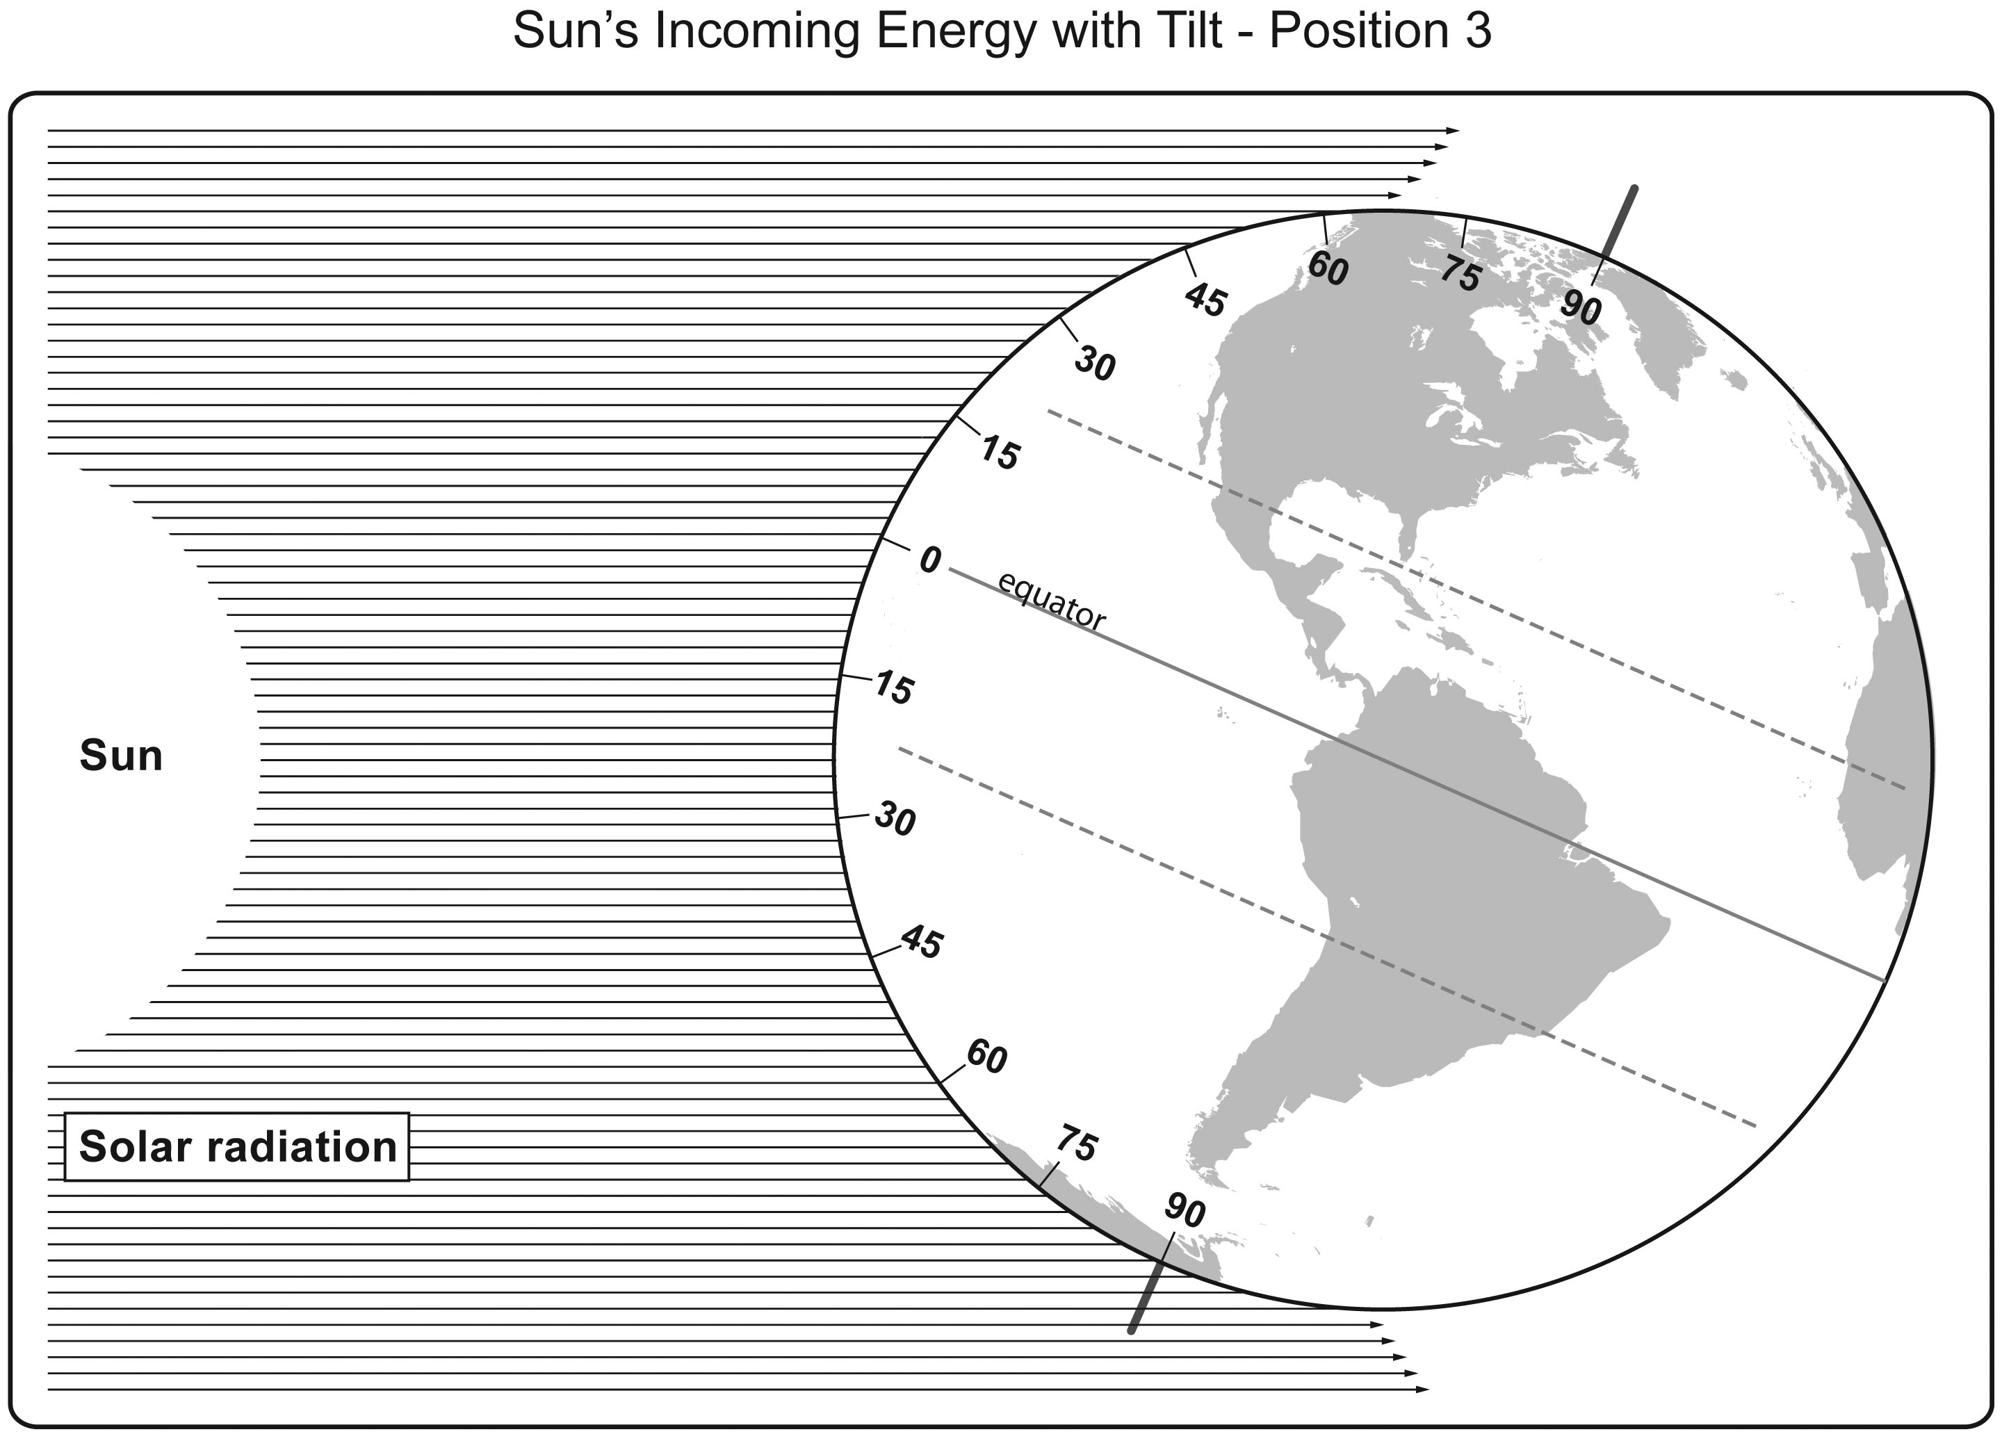
Art adapted with permission from Dr. Lawrence Woolf, General Atomics Sciences Education Foundation

