Name: ___________________________ Hour: _________
Level 1:
- Name the SI unit or units are used for the following measurements:
- Length

- Mass

- Weight

- Volume
2. Label the following graphs with the correct graph type:
a. 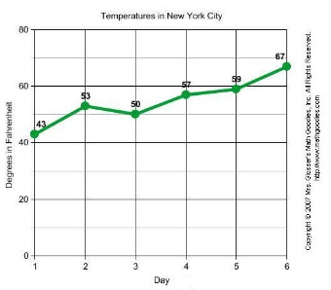 _____________________________
b. 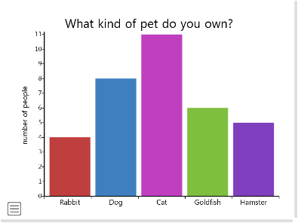 _____________________________
c. 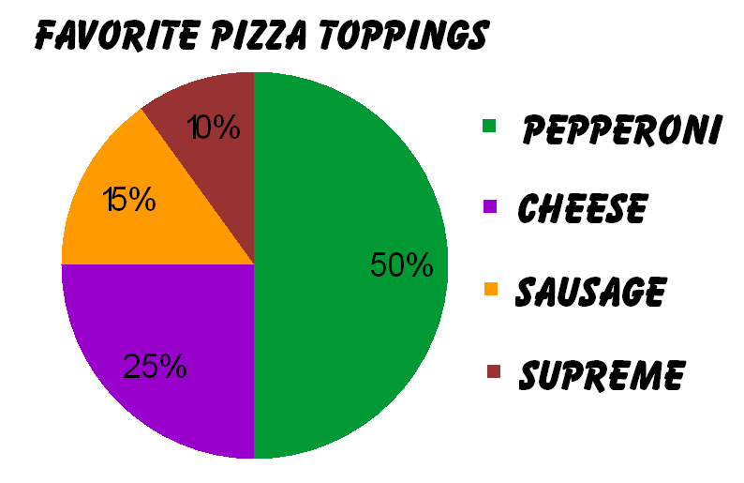 __________________________
d. 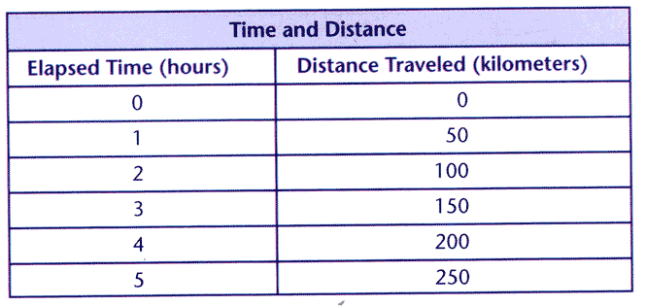 ___________________________

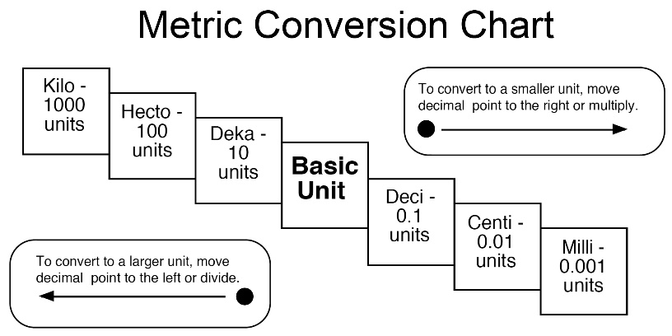
Level 2:
3. Convert the following:
a. 32 millimeters into centimeters.

b. 20.5 kilometers into meters.

c. 40.26 grams into kilograms.

d. 58.29 kilograms into grams.

4. Scientific Method: Filling in the blanks to put the steps in order. The first letter is given to you.
a. A_______________ a Q_______________
b. M_______________ an O_______________
c. F_______________ a H_______________
d. T_______________ your hypothesis by doing an E_______________
e. R_______________ your R_______________
f. A_______________ more Q_______________

Level 3:
5. Mckenzie wants to see how different colored light waves influence the growth of pea plants. She puts the same number of seeds into three identical pots with the same kind and amount of soil. She then gives them the same amount of water every three days for the length of the experiment. One pot is placed into a dark windowless closet. Another pot is left on the windowsill, and the third is placed under a lamp with a green bulb. She records the height of each plant every day for three months.
a. What question could McKenzie use for her experiment?

b. Write a hypothesis for McKenzie, remember to use “I hypothesis that _________ because _______.” or another sentence starter.

c. What is McKenzie’s control for this experiment?

d. What would be McKenzie’s independent variables (the variables that stay the same throughout her experiment)?

