Planet
Standard: The Earth is the 3rd planet from the sun in a system that includes the moon, the sun, seven other planets and their moons and smaller objects.
Benchmark: Compare and contrast the size, locations and compositions of the planets and moons in the solar system (8.3.3.1.4)

Project
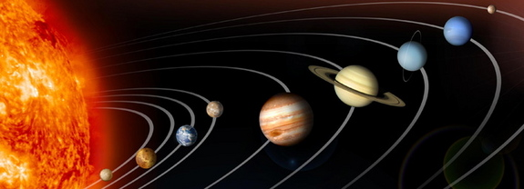

Assignment: Using the internet, books from the library and/or your textbook, find the information listed below for your planet. Including the information you find, you will create a project of your choice (example: model, poster…etc). Use the chart provided for you to keep the information you find about your planet organized. You will use this chart to also record information from projects on other planets.

- What does the planet look like? You must include an artistic interpretation of your planet.
- Have we explored the planet? If so, what spaceships/satellites have been sent there?
- What features have been found on the planet? For example, does it have mountains, volcanoes, ice, ect.?
- What type of atmosphere does your planet have? What gasses are present?
- What is the average temperature? High temperature? Low temperature?
- What is the gravity like on this planet? (Example: If you weighed 100 lbs on Earth, you would weigh ______ lbs on this planet.)
- How many moons does this planet have? What can you tell us about those moons?
- How far away is the planet from the sun (in astronomical units – AU)?
- How long is the revolution/orbit?
- How long is the spin/rotation?
- What is the diameter (km), mass (kg) and density (g/cm3) of the planet?
- What are three other pieces of interesting information, not already included in the questions above, about the planet?

Possible websites:
http://nineplanets.org/
http://solarviews.com/
http://www.jpl.nasa.gov/solar-system/
https://solarsystem.nasa.gov/planets/

