Name: ________________________________________________ Hour: __________ Date: _____________________

1. MERCURY
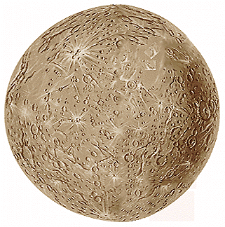
Planet description: _____________________________________________________________________
Planet features: _____________________________________________________________________
_____________________________________________________________________
Distance from the Sun (AU) | Revolution  (year) | Rotation  (day) | Temperature  (*F or *C) | Diameter  (km) | Mass  (kg) | Density  (g/cm³)

Atmosphere: _______________________________________________________________________________________
Explorations: _______________________________________________________________________________________
_______________________________________________________________________________________
Moons: ____________________________________________________________________________________

Other: ___________________________________________________________________________________________
___________________________________________________________________________________________

2. VENUS
Planet description: _____________________________________________________________________
Planet features: _____________________________________________________________________
_____________________________________________________________________
Distance from the Sun (AU) | Revolution  (year) | Rotation  (day) | Temperature  (*F or *C) | Diameter  (km) | Mass  (kg) | Density  (g/cm³)

Atmosphere: _______________________________________________________________________________________
Explorations: _______________________________________________________________________________________
_______________________________________________________________________________________
Moons: ____________________________________________________________________________________

Other: ___________________________________________________________________________________________
___________________________________________________________________________________________

3. EARTH
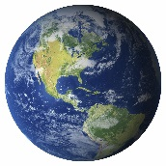
Planet description: _____________________________________________________________________
Planet features: _____________________________________________________________________
_____________________________________________________________________
Distance from the Sun (AU) | Revolution  (year) | Rotation  (day) | Temperature  (*F or *C) | Diameter  (km) | Mass  (kg) | Density  (g/cm³)

Atmosphere: _______________________________________________________________________________________
Explorations: _______________________________________________________________________________________
_______________________________________________________________________________________
Moons: ____________________________________________________________________________________

Other: ___________________________________________________________________________________________
___________________________________________________________________________________________

4. MARS
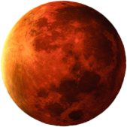
Planet description: _____________________________________________________________________
Planet features: _____________________________________________________________________
_____________________________________________________________________
Distance from the Sun (AU) | Revolution  (year) | Rotation  (day) | Temperature  (*F or *C) | Diameter  (km) | Mass  (kg) | Density  (g/cm³)

Atmosphere: _______________________________________________________________________________________
Explorations: _______________________________________________________________________________________
_______________________________________________________________________________________
Moons: ____________________________________________________________________________________

Other: ___________________________________________________________________________________________
___________________________________________________________________________________________

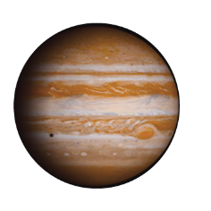
5. JUPITER
Planet description: _____________________________________________________________________
Planet features: _____________________________________________________________________
_____________________________________________________________________
Distance from the Sun (AU) | Revolution  (year) | Rotation  (day) | Temperature  (*F or *C) | Diameter  (km) | Mass  (kg) | Density  (g/cm³)

Atmosphere: _______________________________________________________________________________________
Explorations: _______________________________________________________________________________________
_______________________________________________________________________________________
Moons: ____________________________________________________________________________________

Other: ___________________________________________________________________________________________
___________________________________________________________________________________________

6. SATURN
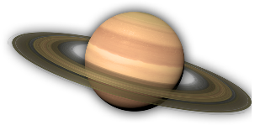
Planet description: _____________________________________________________________________
Planet features: _____________________________________________________________________
_____________________________________________________________________
Distance from the Sun (AU) | Revolution  (year) | Rotation  (day) | Temperature  (*F or *C) | Diameter  (km) | Mass  (kg) | Density  (g/cm³)

Atmosphere: _______________________________________________________________________________________
Explorations: _______________________________________________________________________________________
_______________________________________________________________________________________
Moons: ____________________________________________________________________________________

Other: ___________________________________________________________________________________________
___________________________________________________________________________________________

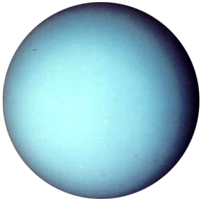
7. URANUS
Planet description: _____________________________________________________________________
Planet features: _____________________________________________________________________
_____________________________________________________________________
Distance from the Sun (AU) | Revolution  (year) | Rotation  (day) | Temperature  (*F or *C) | Diameter  (km) | Mass  (kg) | Density  (g/cm³)

Atmosphere: _______________________________________________________________________________________
Explorations: _______________________________________________________________________________________
_______________________________________________________________________________________
Moons: ____________________________________________________________________________________

Other: ___________________________________________________________________________________________
___________________________________________________________________________________________

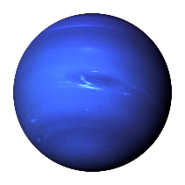
8. NEPTUNE
Planet description: _____________________________________________________________________
Planet features: _____________________________________________________________________
_____________________________________________________________________
Distance from the Sun (AU) | Revolution  (year) | Rotation  (day) | Temperature  (*F or *C) | Diameter  (km) | Mass  (kg) | Density  (g/cm³)

Atmosphere: _______________________________________________________________________________________
Explorations: _______________________________________________________________________________________
_______________________________________________________________________________________
Moons: ____________________________________________________________________________________

Other: ___________________________________________________________________________________________
___________________________________________________________________________________________

