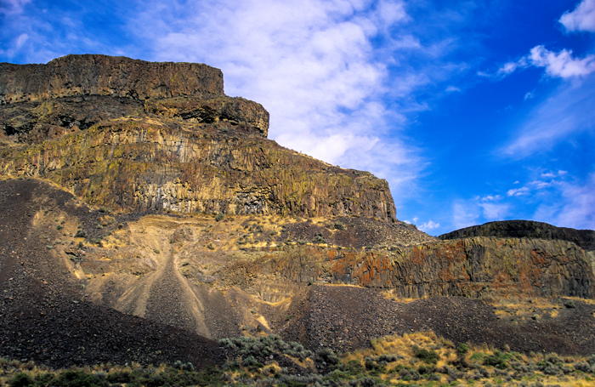

Flood or Plateau Basalt
Characteristics: Very liquid lava, flows very widespread, emitted from fractures.
Examples: Columbia River Plateau

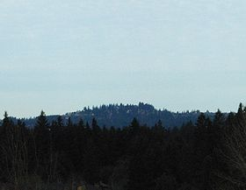
Shield Volcano
Characteristics: Liquid lava emitted from a central vent; large, sometimes has a collapsed caldera.
Examples: Larch Mountain, Mount Sylvania, Hawaiian volcanoes.
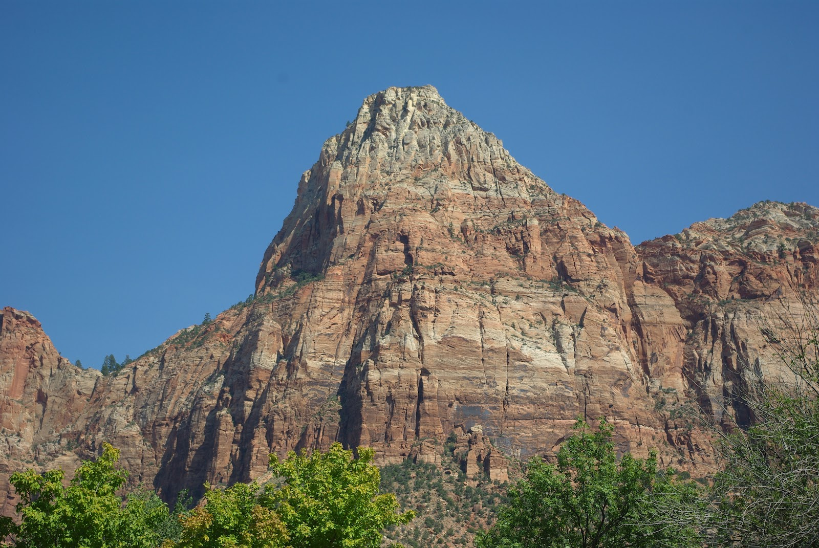

Cinder Cone
Characteristics: Explosive liquid lava from a central vent. Alternating layers of cinders and lava. If eruption continues long enough, may build up a shield volcano.
Examples: Mount Tabor, Mount Zion, Chamberlain Hill

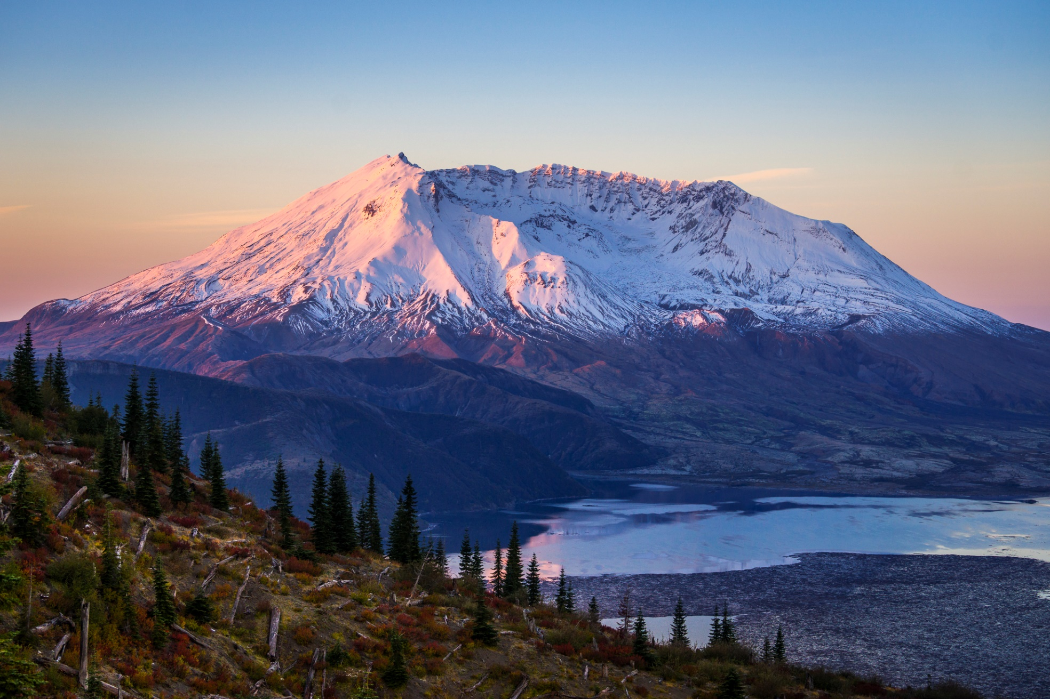
Composite or Stratovolcano
Characteristics: More viscous lavas, large pyroclastic debris, emitted from a central vent.
Examples: Mount Baker, Mount Rainier, Mount St. Helens, Mount Hood, Mount Shasta.

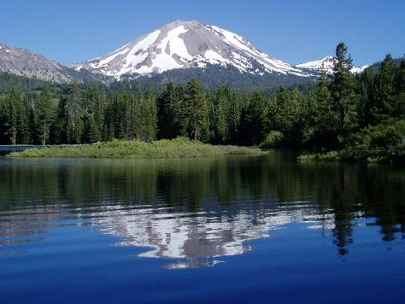
Volcanic Dome:
Characteristics: Very viscous lava, relatively small in size, can be explosive. Commonly occurs adjacent to craters of composite volcanoes.
Examples: Novarupta, Mount St. Helens Lava Dome, Mount Lassen, Shastina, Mono Craters.

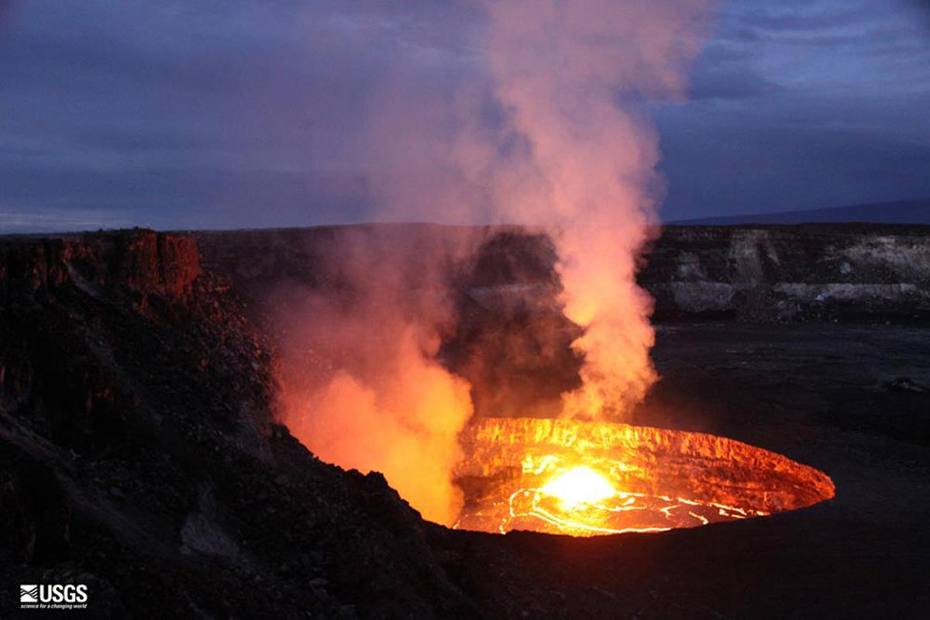
Caldera:
Characteristics: Very large composite volcano collapsed after an explosive period.
Examples: Crater Lake, Newberry, Kilauea, Long Valley, Medicine Lack, Yellowstone.

