Measuring Volume, Mass, and Length
Objective: This lab experiment introduces students to the metric system and allows students to practice using graduated cylinders, balances, and rulers in preparation for a lab practical quiz.
Assignment: Complete the measurements and calculations. Record all data in your notebook by making a data table. Make sure that you are able to measure accurately and precisely, and that you are able to make metric conversions.
Measuring Accurately & Precisely using Metric Units
Directions: Complete the following tasks and create a data table to record all the data into your lab notebook.
Part A: Mass (using a balance)
1. Measure and record the mass of the rubber stopper in grams (g) and kilograms (kg).
2. Measure and record the mass of the paper clip in g and kg.
3. Measure and record the mass of the block in g and kg.
Part B: Volume (using a graduated cylinder, a beaker, and ruler)
4. Measure and record the length, width and height of the block in centimeters (cm) and millimeters (mm). Calculate the volume of the block in cm³, mm³, and mL.
5. Using water displacement, measure the volume of the rubber stopper in mL.
6. Using water displacement, measure the volume of the paper clip.
7. Measure precisely 47 mL of water in a graduated cylinder. Diagram the graduated cylinder from the side.

Part C: Area (calculate using the formula, area = length x width)
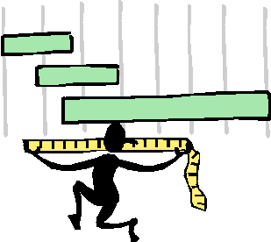
8. Measure and record the length and width of the index card in cm and mm. Calculate the area of the index card in cm² and mm².
9. Measure and record the length and width of your textbook in cm and m. Calculate the area of the textbook in cm² and m².

Part D: Misc.
10. As accurately as you can, measure the surface area of the entire classroom floor in m². Convert to cm².
11. Measure and record the height of each member of your lab group in cm and m. Measure & record the height of each group member's bellybutton.
12. On the floor in the lab, use tape to mark a square meter. Estimate how many people could stand inside the square at once.

Conclusion and Reflection:
In your notebook, explain how you measure volume for a rectangular and irregular object, measure length, and measure mass. Why is being accurate in measurement important in learning science? Answer in complete sentences.

